**Acknowledgement**

Place:

Date:

I would like to express my gratitude toward staff of __________(department) as well as the principal of ______________ (college name) for providing me a great opportunity to complete a project on___________ (topic name).

My sincere thanks go to Shri/Smt ___________ (lecturer name) without his/her support and guidance for the completion of this project.

I am ensuring that this project was done by me and not copied from anywhere.

Name:

Signature:

**TABLE OF CONTENTS**

1. Introduction………………………………………………………….
2. Objectives of project…………………………………………………
3. Feasibility Study……………………………………………………..
   1. Feasibility Study…………………………………………………
   2. System Feasibility……………………………………………….

3.2.1 Operational Feasibility……………………………………..

3.2.2 Technical Feasibility……………………………………….

3.2.3 Economical Feasibility…………………………………….

1. Methodology………………………………………………………..
   1. System Analysis…………………………………………………
   2. Investigation…………………………………………………….
   3. Analysis of investigation………………………………………..
   4. Constraints and limitations………………………………………
   5. Software requirement specification……………………………..
2. Project Introduction…………………………………………………
   1. Introduction……………………………………………………..
   2. Modules…………………………………………………………
3. Data Flow Diagrams………………………………………………..
4. Requirements……………………………………………………….
   1. Hardware Requirement………………………………………….
   2. Software Requirement………………………………………….
5. Technologies Used…………………………………………………
   1. Front-end: ReactJs……………………………………………..
   2. Back-end: NodeJS……………………………………………..
   3. Database: MongoDB…………………………………………..
   4. Server: Node Server……………………………………………
6. Future Scope and Conclusion………………………………………
7. Snapshots…………………………………………………………..

**LIST OF FIGURES**

|  |  |  |
| --- | --- | --- |
| **Figure No.** | **Description** | **Page No.** |
| Figure 5.1. | Homepage with header and search bar |  |
| Figure 5.2. | Homepage (Services we provide) |  |
| Figure 5.3. | Homepage (How we work) |  |
| Figure 5.4. | User signup page |  |
| Figure 5.4. | User login page |  |
| Figure 5.5. | Product page |  |
| Figure 5.6. | User profile page |  |
| Figure 5.7 | Booking History |  |
| Figure 5.8. | Appointment scheduling window |  |
| Figure 5.9. | Payment window |  |
| Figure 5.10. | Booking confirmation email |  |
| Figure 5.11. | Parlour login page |  |
| Figure 5.12. | Parlour signup page |  |
| Figure 5.13. | Parlour dashboard |  |
| Figure 5.14. | Add product section |  |
| Figure 5.15. | Today’s booking history |  |
| Figure 5.16. | All booking history |  |
| Figure 5.17. | All added products |  |
| Figure 5.18. | Parlour profile |  |
| Figure 6.1. | DFD for user or client |  |

**CHAPTER 1**

**INTRODUCTION**

Online Beauty parlour management system is a web-based salon management application with appointment scheduling functionality. In this system user can review salons and stylist online and can make appointment online. In this system beauty parlour owner can make their account online and give details of the services they offer and also describe the stylist information. User can also cancel appointments online. User can also write and reviews about the salon or stylist. This system helps both the customer and the salon. Customer can easily find best salon in their locality and can check the review of other customer of that salon online. It helps him to take decision of taking the services of a particular salon. Online Beauty Parlour Management System (OBPMS) connects clients(users) and saloons (Service providers) in online platform allowing users to browser saloons and book or cancel appointments.

In present system you have to call the salon to fix an appointment. After taking an appointment you have to remember the date of the appointment. User is also not able to find the best salon in their locality. He can find out the services of any salon only after taking their services. But in proposed system you can check review online and find out who is giving best services. Use can also check that which salon gives good customer satisfaction.

In current system salon take appointment on register. They manage customer record on register. And it is very difficult to find out old appointment details in this system. Making report for the salon business is also very tiresome task. this system is prone to costly human error. Online Beauty Parlour Management System allow salon to manage stylists and services, promote sales to customers, and track customer satisfaction.

Online Beauty Parlour Management System is developed to automate all the salon activity. Using this system user can manage their salon and also use this system to book appointment of his customer online. User can also check the top-rated salons in his locality using this system online. User can get the address of the top-rated salon in his locality by clicking on the name of the salon. Users can click on the salon’s name in order to get the address and phone number of the salon. Customer can login into the system by giving valid username and password. After login he can check his upcoming appointments. salon admin can also how many appointments they have to complete on particular date. User can also search any salon by entering its name in the search box.

**CHAPTER 2**

**OBJECTIVE OF PROJECT**

**2.1 Objective**

The main objective of Online Beauty Parlour Management System is saved to time and complexity of work at beauty salon. Online Beauty Parlour Management System is very much effective web application. It is helpful for all the person because the uses of this application are easy. By this anyone can see all types of services for yourself, parlour work and order according to your need. From this web app user can book salon at any time in any saloon in any location. This app is available for books your order anytime and anywhere and books your appointment for service online and use the mode of payment online payment.

This web app help saloon owner to see all detail in brief like total number of customers, total number of appointments, rejected appointments, accepted appointments, total services, today’s sale, yesterday’s sale and total sales. This software helps users to take appointments with beauty parlours on particular date and time. Users view the services offer by the parlours. User can see the details of beauty parlour and can contact with that beauty parlour.

There are more objective of our Online Beauty Parlour Management System described as given below:

* To evaluate best solution for booking online appointments and manage the same.
* To develop the outlook type schedule with different views to display the appointments and perform various actions on that.
* To develop secure web-based access to the Users, Powerful search capability of appointments.
* Development of web applications for salons to manage their daily schedules.
* To manage the accounts of customers, salon owners.
* To implement web-based Payments and confirmation email.

**2.2 Recognition of need**

Generally, Salon hikes a lot in charges of their services. Even their offer is displayed for the limited number of days. Even there is a lot of rush in the salons, which consumes more time.

**2.3 Scope**

The web app is highly flexible one and is well efficient to make easy interactions with the client. The key focus is given on data security, as the project is online and will be transferred in network. The speed and accuracy will be maintained in a proper way. Scope is an individual that involve in some module in Online Beauty Parlour Management System. The future depends on the beauty business. The change that will happen is that the salon, beauty and the wellness businesses will merge as one feel happy when the salon has all these services offered by qualified people treating your face and skin. Five years down the line the industry will be exponentially growing with many aspirational younger people having more jobs and new ventures and that will give a huge boost to the industry and drive the businesses. There is a huge amount of demand for grooming across all age group and especially with young boys and girls. Young people travel abroad all the time they go for work, vacations and they see the trend there.

**CHAPTER 3**

**FEASIBILITY STUDY**

**3.1 FEASIBILITY STUDY**

Before developing this project, we first analyse existed system of study. In existed system all work is performed using papers. As we know, now a day computer is used in every field. We can remove the paper work by using automatic system. We see it first that if it is feasible or not whether technically, economically, operationally. We test that whether it properly works or not. Its technical requirements are feasible or not. We analysed the system properly and then start designing it. After designing, we implement this project that whether this project works properly or not. After implementing the project, we check that whether there is any problem for the user while using this project.

**3.2 SYSTEM FEASIBILITY**

Prior to stating whether the system we have to develop is feasible or not we believe that we should emphasize on what is implied by the word "Feasibility". Feasibility is the measure of how beneficial practical the development of the system will be to the organization. It is a preliminary survey for the systems investigation.

**3.2.1 TYPES**

There are various measures of feasibility that helps to decide whether a particular project is feasible or not. These measures include

* Operational Feasibility
* Technical Feasibility
* Economic Feasibility

**3.2.1.1 OPERATIONAL FEASIBILITY**

A proposed system is beneficial only if it can be turned into an information system that will meet the operational requirements of an organization. A system often fails if it does not fit within existing operations and if users resist the change. Important issues a systems developer must look into are: Will the new system be used if implemented in an organization? Are there any major barriers to implementation or is the proposed system accepted without destructive resistance? The whole purpose of computerizing the Complaint Management is to handle the work much more accurately and efficiently with less time consumption. There will be additional work to be completed, because now the cellular company will have to maintain database of both their employees as well as their Customers. Compared to the semi-computerized system the chances of avoiding errors in a computerized system is much higher because the user need not stress himself unnecessarily resulting in recklessness. Unlike the semi-computerized system there would be backup data for all the information concerning the daily transactions occurred within the organization. Another important fact to be regarded is the security control, which is handled by the system. Since data regarding each Customer and the Organization is confidential, security is a key issue. Information falling into the wrong hands could jeopardize the entire organization. Unlike in semi-computerized systems. The proposed system offers adequate control to protect the organization against fraud and embezzlement and guarantees the accuracy and Security of data and information. This is handled by the system providing individuals with separate login names and passwords.

**3.2.1.2 TECHNICAL FEASIBILITY**

Based on the outline design of the system requirements in terms of inputs, output, Procedures, the technical issues raised during technical feasibility include:

Does the necessary technology exist to do what is proposed?

Does the proposed equipment have the technical capacity to hold the data required to use in the new system?

Adequate responses provided by the proposed system?

Is the system flexible enough to facilitate expansion?

Is there any technical guarantee of accuracy, reliability, ease of access and data security'?

The system developer's task is to view needed capabilities in light of currently available technology. Our site works hand in hand with high technology. A database has to be maintained in order to update and backup data whenever required. To create databases, we use MongoDB. After taking the above

**3.2.1.3 ECONOMIC FEASIBILITY**

In making recommendations a study of the economics of the proposed system should be made. Even though finding out the costs of the proposed project is difficult we assume and estimate the costs and benefits as follows. According to the computerized system we propose, the costs can be broken down in two categories.

* Costs associated with the development of the system.
* Costs associated with operating the system

**CHAPTER 4**

**METHODOLOGY**

The following are the steps we used in the formation of project. To make the project easy to understand and convenient the steps are as follows: -

**4.1 System Analysis: -** System analysis is the process of studying the business processes and procedures, generally referred to as business systems, to see how they can operate and whether improvement is needed

**4.2 Investigation: -** We used the following methods to gather the information

• Document sampling

• Questionnaires

**4.3 Analysis of Investigation**

**•** No complex equipment

• Low cost

**4.4 Constrains and Limitations:**

These limitations and constraints can crop up in almost every system: the most important fact is to find a way to overcome these problems. Software design is the first of three technical activities — design, code generation, and test that are required to build and verify the software. Each activity transforms information in manner that ultimately results in validated computer software.

**4.5 Software Requirement Specification:**

The introduction to software requirements specification states the goals and objectives of the software, describing it in the context of the computer-based system, software engineering is refined by establishing a complete information description, a detailed functional description, a representation of system behaviour, an indication of performance requirement and design.

**CHAPTER 5**

**PROJECT INTRODUCTION**

**5.1 INTRODUCTION**

Online Beauty Parlour Management System is basically a web-based application that is built in ReactJs for frontend development, NodeJS for the backend of the system, MongoDB has been used (i.e. Database) so that it will be easy to retrieve later. Also, the main aim of the system is to help the user to book the appointment in the beauty parlour for online. The system is basically for the users where they can book an appointment in salon / beauty parlour with login. The users of the system include the customers where they can register initially with the minimum details and will be allowed to make an appointment. Moreover, the system has two panels i.e. parlour and User. The user can make an appointment in the parlour and the parlour of the system get information about booking via email. Besides, the user can also modify this scheme according to their requirements. Besides, they can also choose the service which they are trying to get within their specific date and time in the system. All these activities of making appointments such as choosing service as well as date and time will be recorded in the database for all the events. This project integrates a login panel for a more secure system. Moreover, the system also provides contact details so that the user has no difficulty in searching the parlour. Besides, the user can visit parlour at a specific date and time as the system already records the appointment made by them. Thus, the project is a sincere effort in simplifying the task of administrators in an easily usable format. We finalized to make this project and hence planned to develop this system using Visual Studio for writing the code.

**Some Important features are as follow:**

* **Appointment Scheduling**

It is the most important aspect in the beauty & wellness business. Hence, we develop the system that consists of Single appointment with multiple stylists or therapists, Cancelling and rescheduling appointments.

* **Online Booking Mechanism**

Introduce 24/7 appointment booking opportunities in your hair salon with a versatile online booking hair salon & spa software.

* **Increase Client Retention with Feedback Management**

Reputation management is one of the sensitive aspects of the beauty business. With instant feedback tool, we can take control of your salon’s reputation and boost your client relationships. With tricks like a quick survey immediately following their appointments, we will get timely feedback from your clients. It will give you a chance to rectify the issues if there’re any in your spa and salon services.

* **Customer Advance & Package Management**

The package, a combination of multiple services offered within a single package or service, such as: Summer skincare package, Hair shinning package, Bridal package, etc.

The packages get categorized according to the service count and value of every combined service. The service count-based services are generally offered to individuals and the value based offered to celebrities and institutions. The payment made by the customer is in advance during the time of offering package, which reduces as the client avail the services. The packages are time base, which makes it necessary for we to track the expiry of customer advance.

* **Security**

As technology is advancing, the rate of digital threats and hacking incidents have also risen. When you integrate client data, employee data, and point of sale systems with online systems, you should make sure that the system is secure. Hacking is a very big deal, which can cause the downfall of your business with a blink of an eye. Another risk is of employee theft and fraud. The software has the ability to restrict staff access to certain aspects of your system. You can create the roles and configure their access according to your choice.

* **Performance Analyzer**

The smart dashboard in the software enables you to keep track of your hair salon’s performance. You can configure the target for a month, quarter, or year, and compare with the real data. You can also set targets for branch or location growth, stylist or therapist performance, client acquisition, and inventory turnover. It will help you to plan effective marketing strategies.

**5.2 MODULES**

Our proposed system consists of two modules, one module for user or client from where user can book appointment and cancel or rescheduling according to time availability of user as well as parlour. Other module is for parlour owner where they can track the appointment and payment status as well as their performance also.

**5.2.1 USER OR CLIENT MODULE**

The user module allows users to register, log in, book appointment and log out. Users benefit from being able to sign on because this associates content they create with their account and allows various permissions to be set for their roles.

The user module supports user roles, which can be set up with fine-grained permissions allowing each role to do only what the administrator permits. Each user is assigned one or more roles.

**Homepage:** This page consists of overview of Online Beauty Parlour Management system, how it works, what are the features of it and what type of service provided by it.



Figure 5.1. Homepage with header and search bar





Figure 5.2. Homepage (Services we provide)

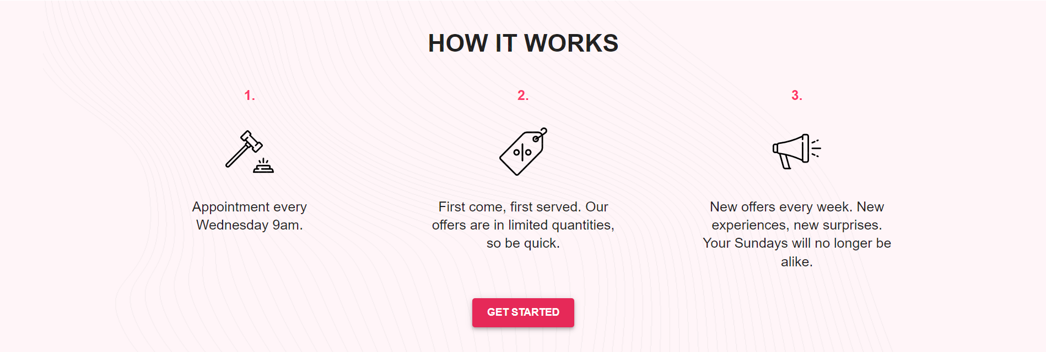

Figure 5.3. Homepage (How we work)

**Signup:** Using this page, user can register yourself using First Name, Last Name, Mobile Number, Email id and password. Each field is protected with some validation method using regular expressions.

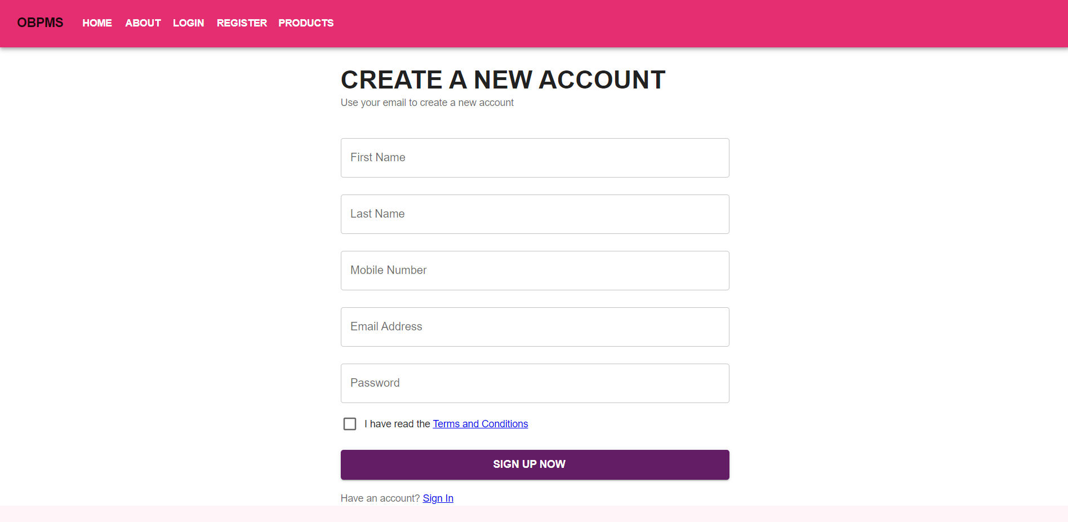

Figure 5.4. User signup page

**Login Page:** User can login using email id and password to book appointment.

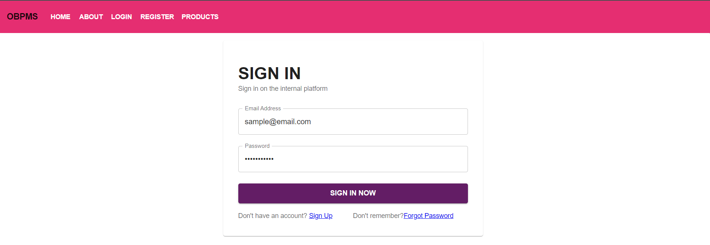

Figure 5.4. User login page

**Product Page:** This page will display all products added by different parlours having information such as product name, description, parlour name, price and time required to complete that task by parlours.

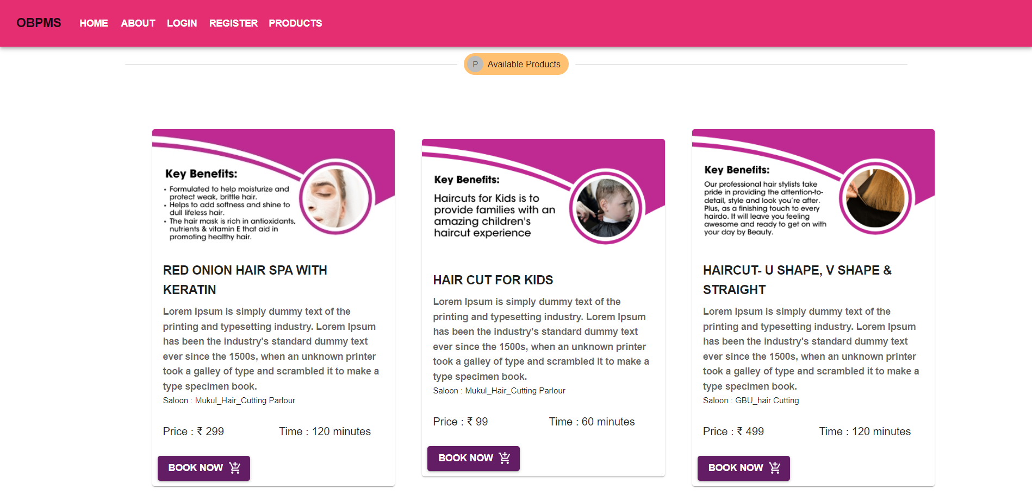

Figure 5.5. Product page

**User profile:** This section consists of all information about users filled during signup process.

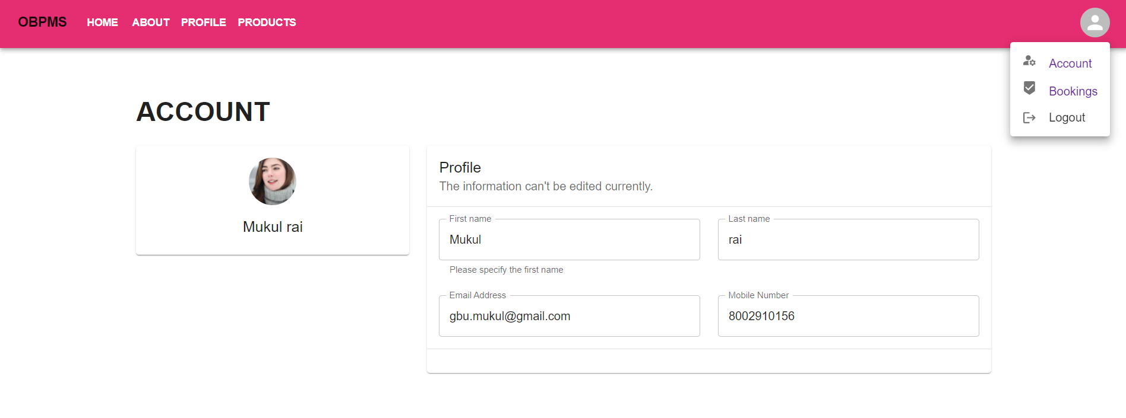

Figure 5.6. User profile page

**Booking History:**  This section shows all appointments booked by the user logged in.

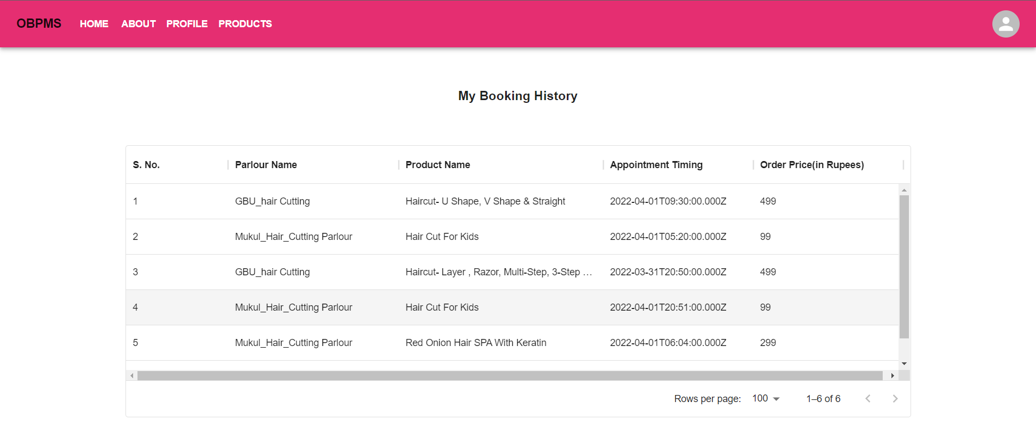

Figure 5.7. User profile page

**Appointment window:** This window will open after selecting to book appointment for particular appointment by filling their choice of time.

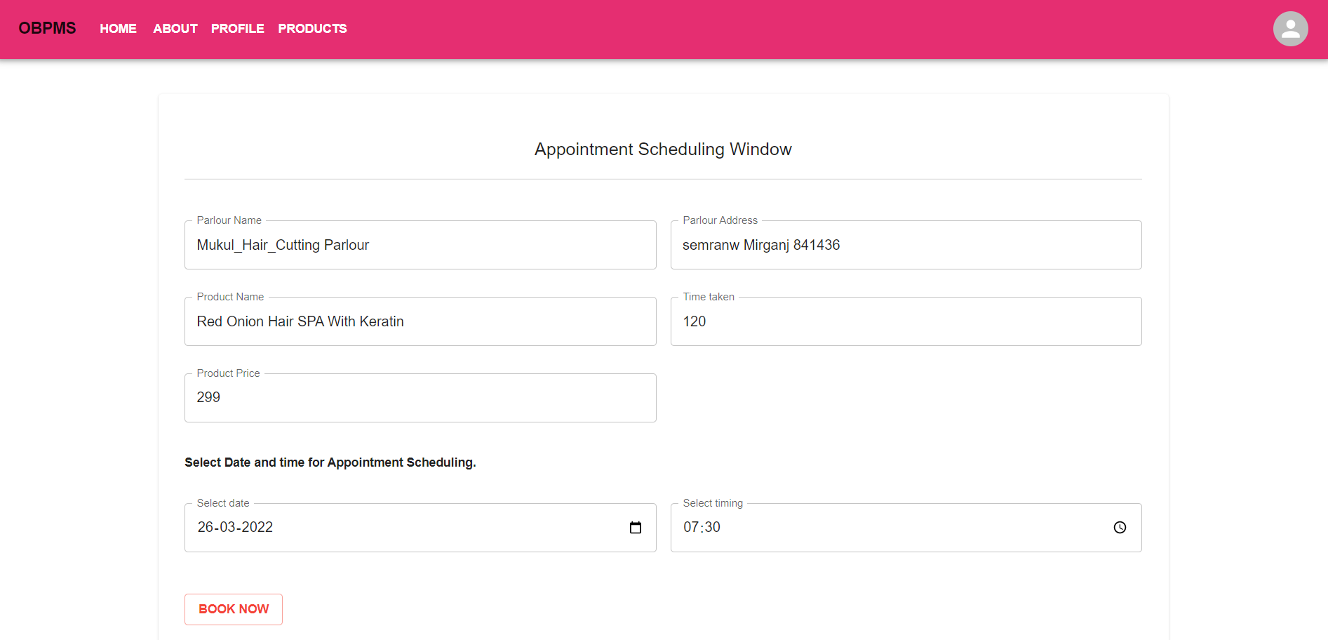

Figure 5.8. Appointment scheduling window

**Payment window:** This window will open after appointment scheduling window. After entering all payment information like credit card, debit card, upi or any wallets for payment.

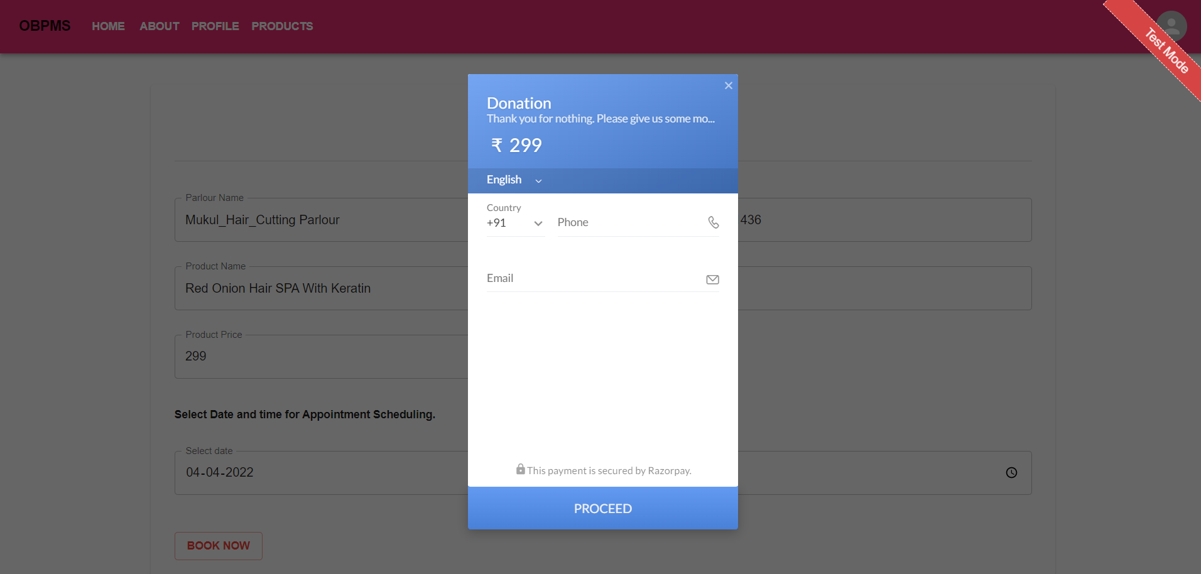

Figure 5.9. Payment window

**Confirmation mail:** This will be the confirmation mail will send to registered email id.

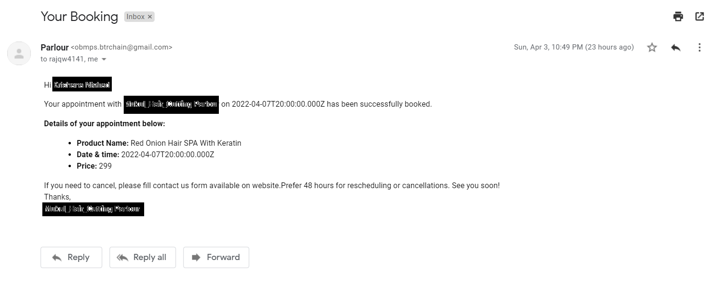

Figure 5.10. Booking confirmation email

**5.2.2 PARLOUR OR SALOON MODULE**

This module allows parlour or saloon to register, log in, view today appointments, all appointment, total earning data and log out. Users benefit from being able to sign on because this associates content they create with their account and allows various permissions to be set for their roles. This module supports user roles, which can be set up with fine-grained permissions allowing each role to do only what the administrator permits. Each user is assigned one or more roles.

**Login Page:** User can login using email id and password to book appointment.

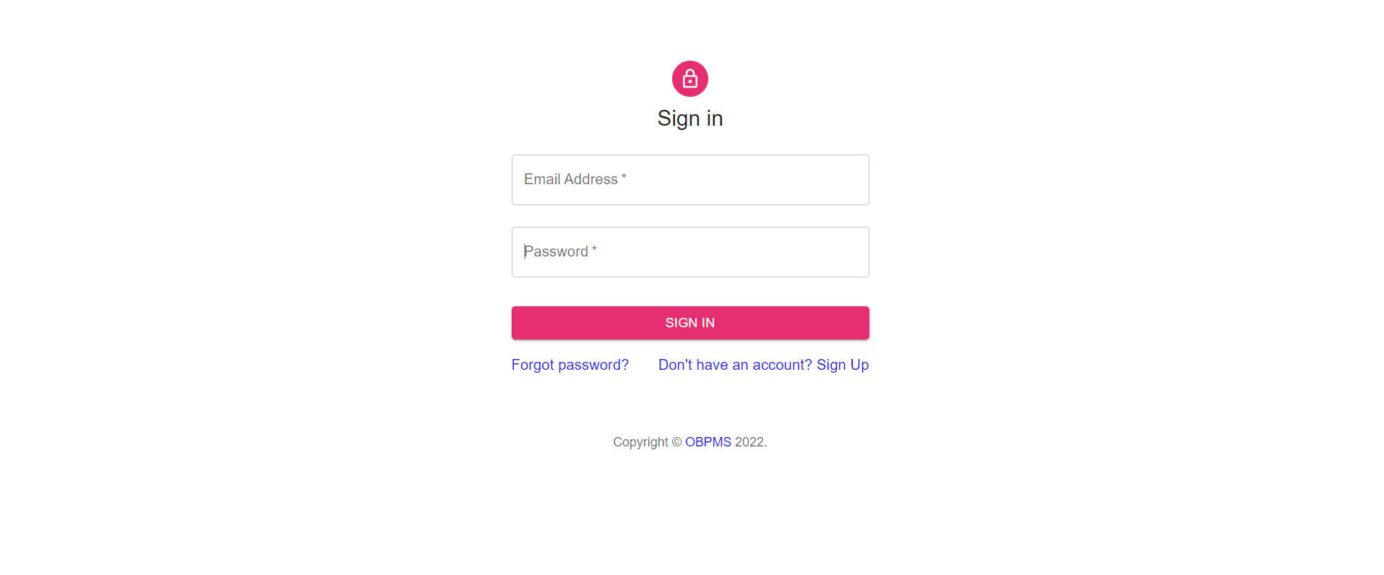

Figure 5.11. Parlour login page

**Signup:** Using this page, parlour can register yourself using First Name and Last Name of saloon, Mobile Number, address, Email id and password. Each field is protected with some validation method using regular expressions.

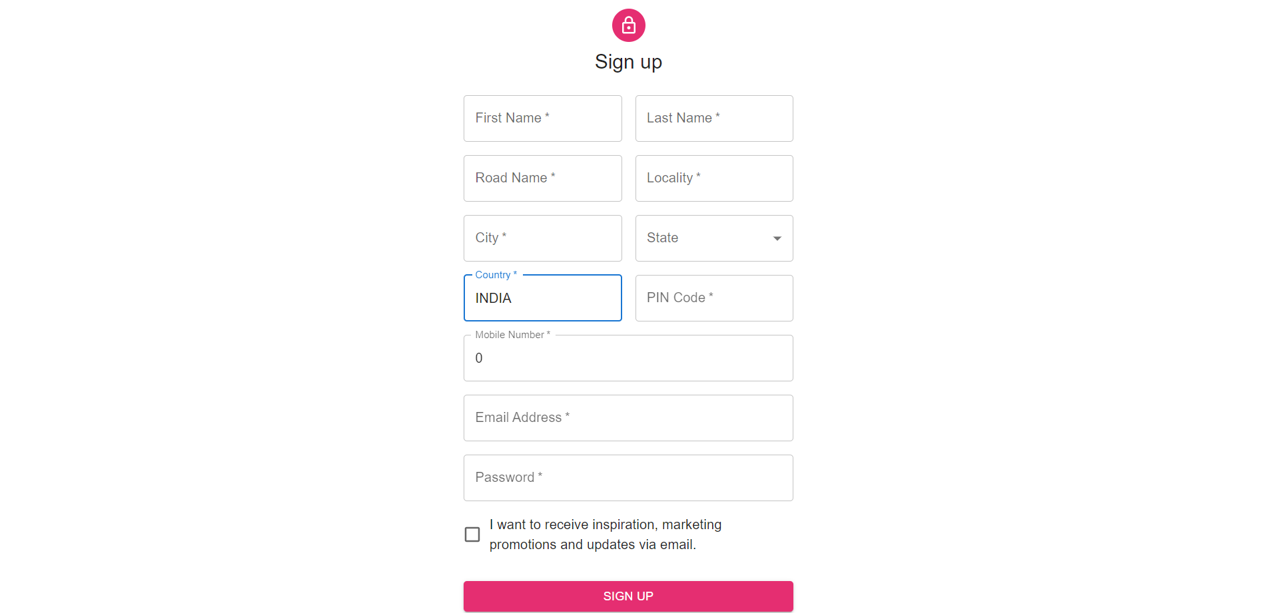

Figure 5.12. Parlour signup page

**Parlour Dashboard:** This window shows all details such as todays appointments, total earnings and total customer served today.

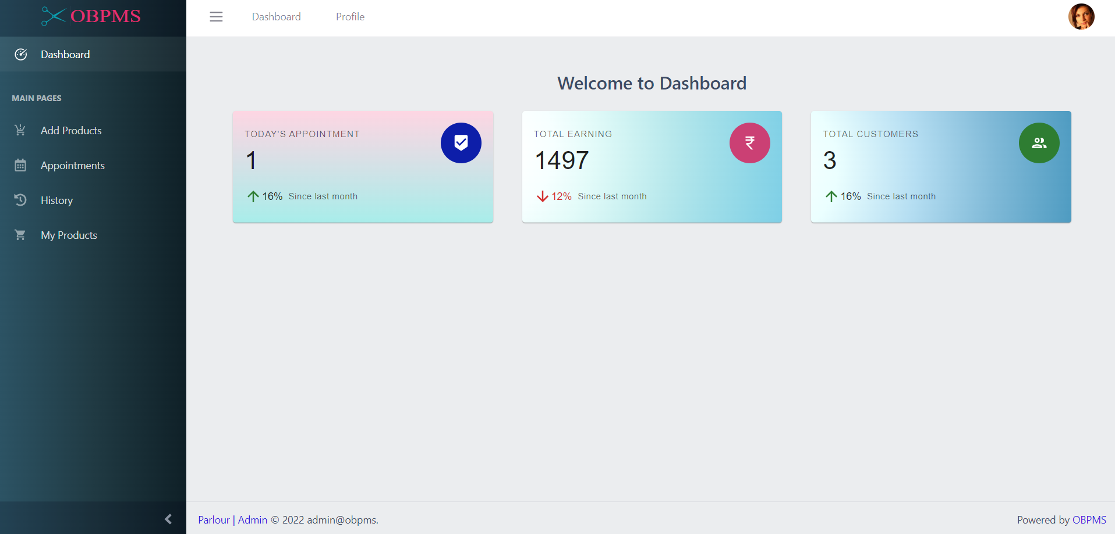

Figure 5.13. Parlour dashboard

**Add product:** Using this window parlour can add their variety of products and services by filling name, duration, description and image of product and services

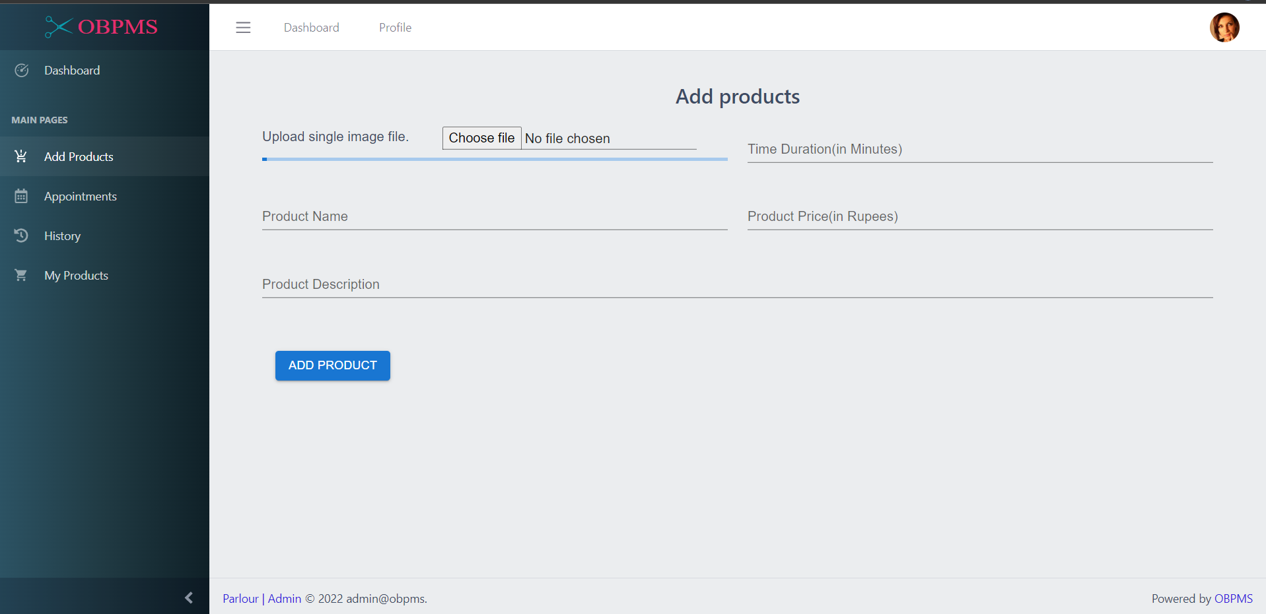

Figure 5.14. Add product section

**Today’s booking history:** This window shows today’s bookings and also it can be filtered in alphabetical order of product, pricing order and username.

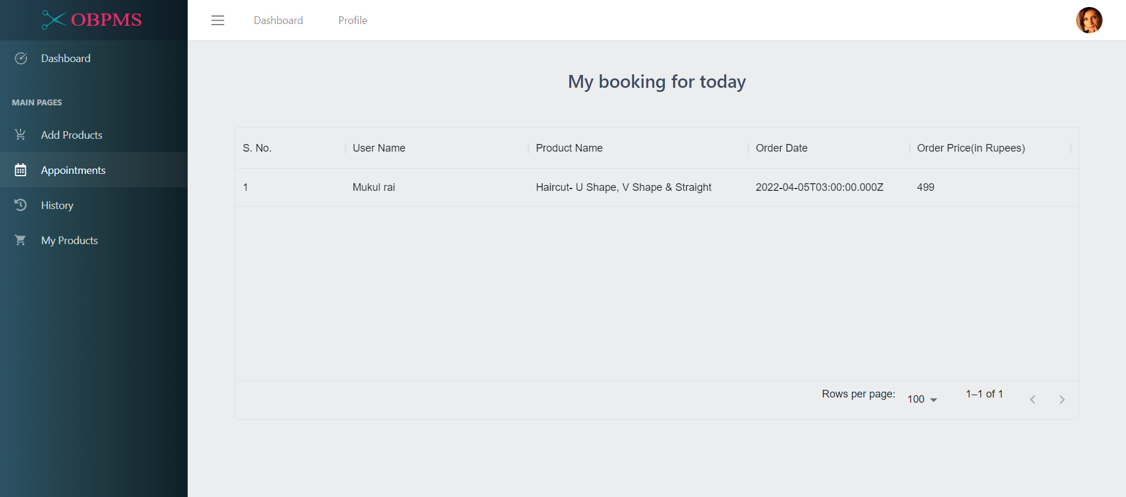

Figure 5.15. Today’s booking history

**All booking history:** This window shows all booking history and also it can be filtered in alphabetical order of product, pricing order and username.

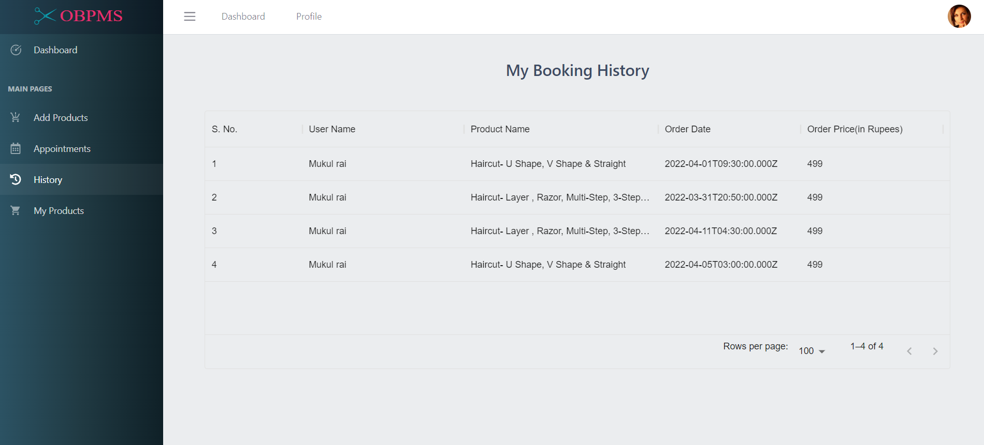

Figure 5.16. All booking history

**Added products:** This window shows all products with details added by logged in parlour.

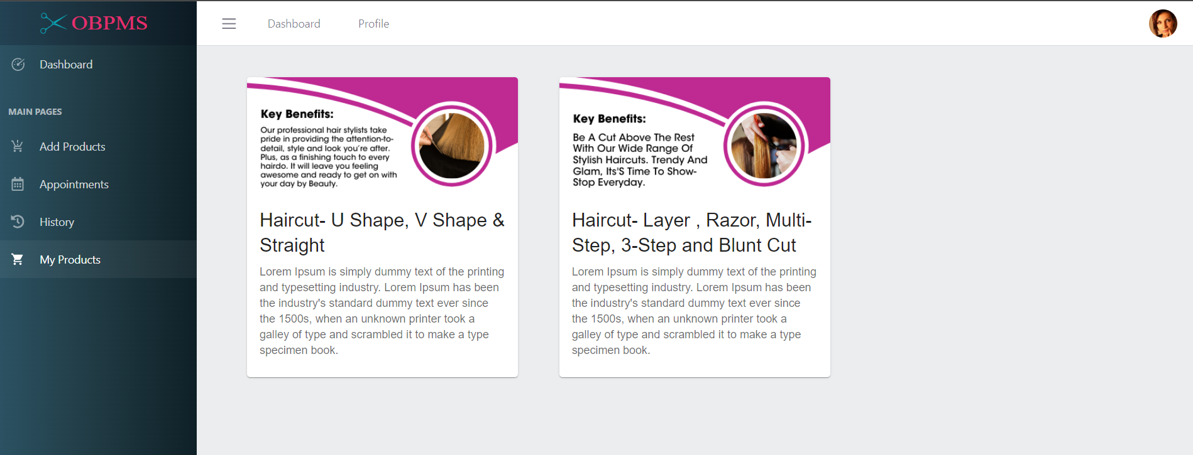

Figure 5.17. All added products

**Parlour Profile:** This window will show profile of parlour from data used during signup by the parlour.

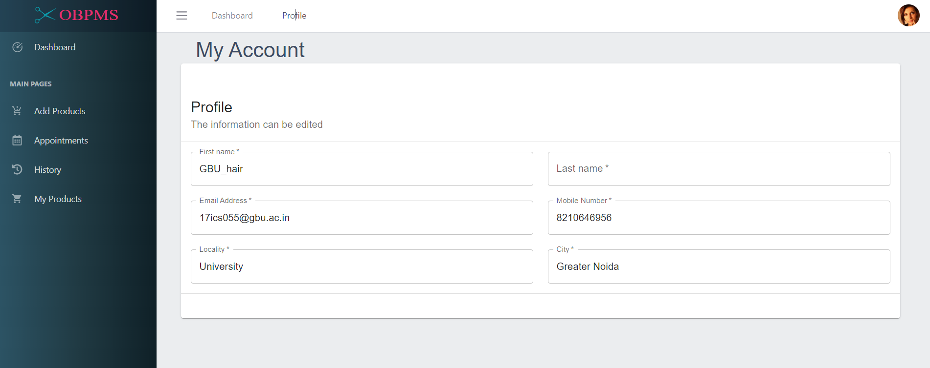

Figure 5.17. Parlour profile

**CHAPTER 6**

**DATA FLOW DIAGRAM**

Data flow diagram is a graphical representation of flow of data in an information system. It is capable of depicting incoming data flow, outgoing data flow and stored data. The DFD does not mention anything about how data flows through the system.

Data flow from user have to create account by filling all information in signup page then login using email id password used during sign up process, then user have to choose the service want to book then payment then appointment confirmed.

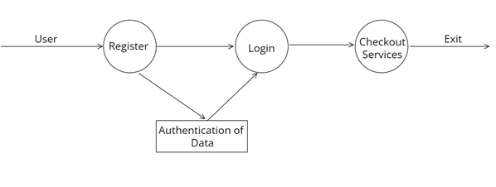

Figure 6.1. DFD for user or client

**CHAPTER 7**

**REQUIREMRNTS**

**7.1. HARDWARE REQUIREMENT**

This web app is required following hardware for smooth working.

| **Component** | **Minimum requirement** |
| --- | --- |
| Processor | 32-bit, 2-cores, 2.5 GHz minimum per core |
| RAM | 4 GB |
| Hard disk | 10 GB |

**7.2. SOFTWARE REQUIREMENT**

* NodeJS
* Visual Studio
* Windows 10/11 or Any Linux distribution
* MongoDB

**CHAPTER 8**

**TECHNOLOGIES USED**

We used following technologies to develop this Online Beauty Parlour Management system.

**8.1. ReactJs**

ReactJS is a declarative, efficient, and flexible JavaScript library for building reusable UI components. It is an open-source, component-based front-end library responsible only for the view layer of the application. It was created by Jordan Walke, who was a software engineer at Facebook. It was initially developed and maintained by Facebook and was later used in its products like WhatsApp & Instagram. Facebook developed ReactJS in 2011 in its newsfeed section, but it was released to the public in the month of May 2013.

Today, most of the websites are built using MVC (model view controller) architecture. In MVC architecture, react is the 'V' which stands for view, whereas the architecture is provided by the Redux or Flux.

A ReactJS application is made up of multiple components, each component responsible for outputting a small, reusable piece of HTML code. The components are the heart of all React applications. These Components can be nested with other components to allow complex applications to be built of simple building blocks. ReactJS uses virtual DOM based mechanism to fill data in HTML DOM. The virtual DOM works fast as it only changes individual DOM elements instead of reloading complete DOM every time.

To create React app, we write React components that correspond to various elements. We organize these components inside higher level components which define the application structure. For example, we take a form that consists of many elements like input fields, labels, or buttons. We can write each element of the form as React components, and then we combine it into a higher-level component, i.e., the form component itself. The form components would specify the structure of the form along with elements inside of it.

**8.2. NodeJS**

Node.js is an open-source and cross-platform JavaScript runtime environment. It is a popular tool for almost any kind of project!

Node.js runs the V8 JavaScript engine, the core of Google Chrome, outside of the browser. This allows Node.js to be very performant.

A Node.js app runs in a single process, without creating a new thread for every request. Node.js provides a set of asynchronous I/O primitives in its standard library that prevent JavaScript code from blocking and generally, libraries in Node.js are written using non-blocking paradigms, making blocking behaviour the exception rather than the norm.

When Node.js performs an I/O operation, like reading from the network, accessing a database or the filesystem, instead of blocking the thread and wasting CPU cycles waiting, Node.js will resume the operations when the response comes back.

This allows Node.js to handle thousands of concurrent connections with a single server without introducing the burden of managing thread concurrency, which could be a significant source of bugs.

Node.js has a unique advantage because millions of frontend developers that write JavaScript for the browser are now able to write the server-side code in addition to the client-side code without the need to learn a completely different language.

In Node.js the new ECMAScript standards can be used without problems, as you don't have to wait for all your users to update their browsers - you are in charge of deciding which ECMAScript version to use by changing the Node.js version, and you can also enable specific experimental features by running Node.js with flags.

**8.3. MongoDB**

MongoDB is an open-source document database that provides high performance, high availability, and automatic scaling. In simple words, you can say that - Mongo DB is a document-oriented database. It is an open source product, developed and supported by a company named 10gen. MongoDB is available under General Public license for free, and it is also available under Commercial license from the manufacturer. The manufacturing company 10gen has defined MongoDB as: "MongoDB is a scalable, open source, high performance, document-oriented database." - 10gen. MongoDB was designed to work with commodity servers. Now it is used by the company of all sizes, across all industry.

## **History of MongoDB**

The initial development of MongoDB began in 2007 when the company was building a platform as a service similar to window azure.

Window azure is a cloud computing platform and infrastructure, created by Microsoft, to build, deploy and manage applications and service through a global network.

MongoDB was developed by a New York based organization named 10gen which is now known as MongoDB Inc. It was initially developed as a PAAS (Platform as a Service). Later in 2009, it is introduced in the market as an open source database server that was maintained and supported by MongoDB Inc.

The first ready production of MongoDB has been considered from version 1.4 which was released in March 2010.

MongoDB2.4.9 was the latest and stable version which was released on January 10, 2014.

## **Purpose of building MongoDB**

It may be a very genuine question that - "what was the need of MongoDB although there were many databases in action?"

**There is a simple answer:**

All the modern applications require big data, fast features development, flexible deployment, and the older database systems not competent enough, so the MongoDB was needed.

**The primary purpose of building MongoDB is:**

* Scalability
* Performance
* High Availability
* Scaling from single server deployments to large, complex multi-site architectures.
* Key points of MongoDB
* Develop Faster
* Deploy Easier
* Scale Bigger

**CHAPTER 9**

**FUTURE SCOPE AND CONCLUSION**

The application is yet to be released and a lot of enhancements are already thought of which proposal are to be implemented in the final version of the web application.

The system is highly flexible one and is well efficient to make easy interactions with the client. The key focus is given on data security, as he project is online and will be transferred in network. the speed and accuracy will be maintained in a proper way.

This will be a user-friendly one and can successfully overcome strict and serve validation checks. The system will be a flexible one and changes whenever can be made easy. Using the facility and flexibility in NodeJS and MongoDB, the software can be developed in a neat and simple manner there as a front -end and node server as a back-end it can be modified easily and used for a long period.

**Conclusion:**

Working on the project was good experience. We understand the importance of the planning and designing as apart of software development but it's very difficult to complete the program for a single person. Developing the project has helped us some experience on real-time development procedures.

**CHAPTER 10**

**BIBILIOGRAPHY**

1. ReactJS - <https://reactjs.org/>
2. Nodejs - <https://nodejs.org/>
3. MongoDB - <https://www.mongodb.com/>
4. Visual Studio - <https://visualstudio.microsoft.com/>